WFTF Resolution nº 22 / 2018

“2020 World Championship Host”

Dear WFTF RGB members,
Dear EFTF President Stanislav Trušakov,

I’m pleased to announce SOUTH AFRICA has accepted to host the World Field Target Championship 2020.

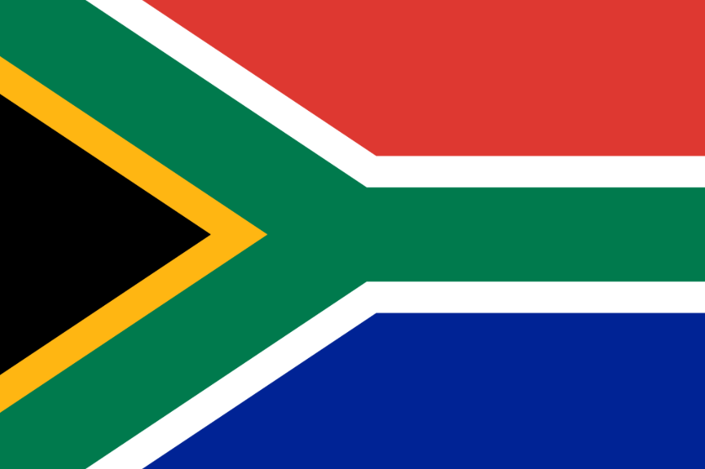
The WFTF wishes SOUTH AFRICA good luck and I’m sure we will see a serious commitment to present us a high quality venue.

Here are some milestones requested to SOUTH AFRICA for the next year:
• 2nd Quarter 2019 – Creation of a WFTC2020 Facebook account;
• 3nd quarter 2019 – Official Date selected for the Championship;
Other relevant general information (Logos, competition area, etc…);
• August 2019– Formal presentation during the WFTC2019 - Ceremony dinner);
• October 2019 – Beginning of inscriptions WFTC 2020;

Sincerely,

_____________
Sergio Rita
WFTF President

02th November 2018

Internal Communication nº 26 / 2018

“2020 World Championship Host”

Dear WFTF RGB members,
Dear EFTF President Stanislav Trusakov,

According to the WFTF rules I request the following RGBs (by order starting with Malta) to analyze and answer the availability and power to host the 2020 World Championship:

This is the current status:

- 2019 ENGLAND | - 2040 GERMANY
- 2020 USA | - 2041 VENEZUELA
- 2021 NORTHERN IRELAND | - 2042 TURKEY
- 2022 CANADA | - 2043 NEW ZEALAND
- 2023 BRAZIL | - 2044 SLOVENIA
- 2024 SOUTH AFRICA | - 2045 NETHERLANDS
- 2025 LATVIA | - 2046 RUSSIA
- 2026 AUSTRIA | - 2047 LITHUANIA
- 2027 BULGARIA | - 2048 COLOMBIA
- 2028 ESTONIA | - 2049 PORTUGAL
- 2029 HUNGARY | - 2050 MALTA
- 2030 BELGIUM | - 2051 WALES
- 2031 CHILE | - 2052 UKRAINE
- 2032 SLOVAKIA | - 2053 SCOTLAND
- 2033 ITALY | - 2054 SPAIN
- 2034 AUSTRALIA | - 2055 EL SALVADOR
- 2035 ARGENTINA | - 2056 IRAN
- 2036 NORWAY | - 2057 POLAND
- 2037 FRANCE
- 2038 CROATIA
- 2039 SWEDEN

Sincerely,

_____________
Sérgio Rita
WFTF President

02ND September 2018

Rules:

- Country Host Priority: According to the WFTF rotating host countries list;
- Important: The absence of an answer will pass the organization to the next country in the rotating list.

