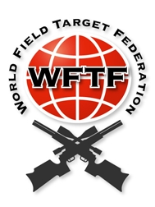
World Field Target Federation

Constitution

Contents
1. DEFINITIONS 3
2. AIMS 3
3. MEMBERSHIP 3
4. MANAGEMENT 3
5. MEETINGS 3
6. CONSTITUTION CHANGES 3
7. FINANCES 4
8. WORLDS HOST 4
9. ANNEXURE A 4
10. ANNEXURE A1 5

DEFINITIONS

The body shall be known as the World Field Target Federation, hereinafter referred to as the ‘Federation’.

AIMS

The aim of the Federation is to provide a link between Field Target shooters worldwide and to govern the World Championships.

MEMBERSHIP

Membership of the Federation shall be open to properly constituted Representative Governing Bodies (RGB’s).

Acceptance of an RGB will be by majority agreement of those senior/sole member RGB’s at the time of application.

In the case where an alternate organisation wishes to obtain recognition as RGB, it must submit, together with its application, written proof of its membership/affiliation to a higher shooting/sport federation of that country.

Where more than one RGB from the same country has been admitted to the WFTF, the RGB with the greater number of shooters participating in the most recent/current World Championships will be the senior RGB.

Only the senior or sole RGB of a country may vote on Federation matters or nominate teams at a World Championship.

MANAGEMENT

The Federation will be managed by a President who will be elected by nomination and a majority vote from the RGB’s at the time of an annual World Championships event.

The President will serve for a period of three years and will be responsible for representing and running the Federation, with only supervisory powers over World Championship events.

MEETINGS

The Federation will not meet in conference or committee.

All relevant business will be transacted by document with copies to all member RGB’s, thereby ensuring that all records and transactions of the Federation are fully available to and complete at every member RGB.

At the time of change of management of the Federation there will be no requirement for the transfer of records.

All members RGB’s will be responsible for advising the President of their Federation contacts.

CONSTITUTION CHANGES

The Constitution of the Federation may only be changed at the end of each hosting period, and then only by a simple majority agreement of the member senior/sole RGB’s.

FINANCES

The Federation will not hold funds or property in any form, nor will it be liable for debts of any nature.

Any costs incurred in any way in connection with the Federation business will be borne in whole by the host RGB.

Any excess of income over expenditure arising from a Federation event will fall to the host RGB.

Each World Championship Organizer based on the inscriptions will have to pay the annual fee of the WFTF website hosting.

(note: the cost is around 50€?)

WORLDS HOST

The host RGB will each year organise and host the World Field Target Championships on behalf of the Federation.

The appointment of host countries will be done according to the WFTF policy on rotating World FT Championship host countries as reflected in Annexure A.

When a country offers to host the Worlds acceptance of hosting is subject to approval by majority vote of the RGB's.

As a preliminary and necessary condition to host and organize the WFTC, the candidate RGB has to commit to fully accept and apply the Constitution and Comprehensive Rules, as they are established by the WFTF RGB members.

The host will need to provide information like number of competitors possible to have in the competition, number of sessions, expected light hours, temperatures and other relevant information requested by the RGB’s.

The organising and management of a World Championship event will be the responsibility of the Chairman of the host RGB, who will serve as Vice President of the Federation from the end of the previous Championship to the end of the Championship that they will be hosting.

The host RGB may at its discretion expand or add to the Championships providing that such action does not in any way reduce the Field Target content of the event nor does it create any reward deemed to be higher than the purpose of the Championship.

Host RGB rules will apply at all Federation Championships, but may not contradict/override the WFTF Core Rules.

Participation of a WFTF event in breach of these rules will not be permitted.

ANNEXURE A
WFTF POLICY ON ROTATING WORLD FT CHAMPIONSHIP HOST COUNTRIES

Policy

As was agreed by NGB's in April 2008, a The policy of rotating FT Worlds host countries has been accepted, based on the following principles, namely that:

A master list containing all member countries of the WFTF was agreed upon as is reflected in Annexure A1.

The member at the top of the list is offered first refusal to host the following year's FT World Championships (2009 onwards).

Subsequent Worlds will be offered to NGB's according to the sequence in Annexure A1.

New NGBs' names shall be added to the bottom of the list.

Procedure

After every World Championship (August / September) the sitting WFTF chairman will advise the top three NGB's in Annexure A1 of their positions on the list.

The NGB in position number one on the list will respond to the chairman within 20 days in one of the following three ways:

Accept responsibility for hosting the following year's Worlds.

Request to be moved between one and three positions down the list.

Indicate that they are not in a position/interested to host a Worlds, and be moved to the bottom of the list in Annexure A1.

If the NGB in position one on the list does not accept responsibility to host the following year's Worlds (10.2.2a), the chairman will immediately request the next NGB on the list, and the steps above will be repeated, until an NGB accepts.

Once an NGB has accepted, the chairman will update Annexure A1 and advise all ngb's of which ngb will be hosting the following year's worlds. He will also distribute a copy of the updated Annexure A1 to all ngb's.

ANNEXURE A1
WFTF MASTER LIST: ROTATING FT WORLDS HOST COUNTRIES

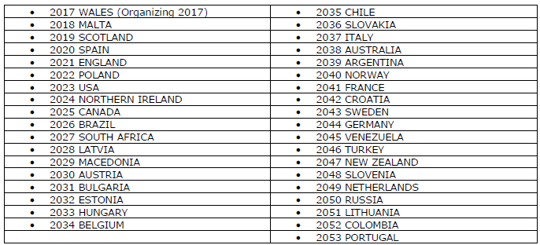

(List is not currently updated)

