OFFICIAL INVITATION

XVIII WORLD FIELD TARGET CHAMPIONSHIPS

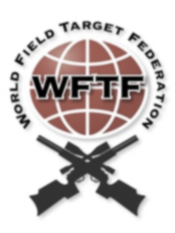
POLAND 2018

Dear Name Surname

On behalf of the World Field Target Federation and OSPST “PFTA” we are pleased to invite you as a competitor to the XVIII WORLD FIELD TARGET CHAMPIONSHIPS, which will be held at the disused quarry in Niegowonice called "KANION" (Poland) from the 20th August to 26th August 2018.

All rifles will be limited to sub 16 Joules/12 ft/lbs.

We kindly inform that Polish law (according to “Ustawa z dnia 21 maja 1999 r. o broni i amunicji") does not require a European weapons passport or any other permission for airguns, which does not exceed 17J.

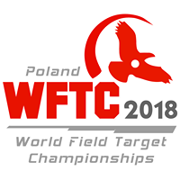

Yours Sincerely,
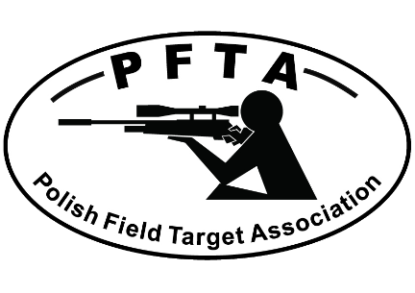
_____________
Paweł Grabowski
OSPST “PFTA” President

